# FixMixAI — Full Development Plan

---

## For the Coordinator Agent — Read This First

If you are an agent reading this document, you are the **Coordinator**.

Your role:
- You are Gemini. You coordinate — you do not write code or make technical decisions alone
- Your first action is to read all Skills listed in the "Skills & Rules Reference" section below
- Your second action is to have an opening conversation with Tsafrir to clarify any open questions
- Your third action is to run the AGENT_ROSTER skill to define the Sub-Agent team
- You speak with Tsafrir in Hebrew. Technical terms stay in English
- You never start Phase 1 work before the dashboard is live

---

## The Problem

AI desktop apps (Claude Desktop, Cursor, ChatGPT, Sider, and more) display
Hebrew and Arabic text with broken direction when mixed with English.

Example of broken text:
"השתמשתי ב React כדי לבנות local app".
(The word "React" in the middle of a Hebrew sentence, and "local app" at the beginning, causes the whole line to render left-to-right, making the it appear in wrong order).
In correct RTL+ mix Languages It should be order
"השתמשתי ב React כדי לבנות" local app
No solution exists today for desktop apps — only browser extensions for Chrome.
- Now, please read " הגדרת הבעיה, חווית משתמש, מקרי שימוש" file in docs. folder before continuing, since it will widen the problem & solution understanding.
---

## The Product

A local desktop app for windows:
1. Reads text from AI desktop (most important) + Browser+ side bar apps using Windows UIAutomation.
2. Detects RTL/English direction mixing in AI apps. In windows of chats+ Artifacts with text displays (such as Tables), and in the future more text displays in AI apps.
3. Displays the corrected text. - best UX/UI would be a seamless overlay window on top of the original app's window- But: keeping interactive elements areas active- overlay must not block buttons or input.
4. more features such as "To magnetize and demagnetize" the overlay display, to save and to share with RTL formatting tables and texts according to user decision, and more later.
5. Need to decide how UI works- does the Fixmix overlay will have a Window frame glows when active? How user chooses which window to active and how many windows can be activate in parallel without slowing down programs and mouth movement? Will FixMixAI will have a control panel or another way to choose wich windows to activate, Language selection, appearance selection, and more.

+The user sees the corrected version and can copy from it.
It works on any AI app (Desktop first but also Browser apps if using UIAutomation will read the same from broser apps.

**Product name:** FixMixAI
**Target users:** RTL-language AI users (Hebrew, Arabic, Persian, Urdu)

**Commercial product** — Phase 3 includes installer, code signing, distribution, Monetization.

---

## Why UIAutomation

UIAutomation is a Windows accessibility API. It reads actual text characters
from any Windows app — Electron apps, native apps, Chrome-based apps.
It does NOT capture pixels. This means:
- It works even when the app uses custom rendering
- It captures the exact characters, so RTL fixing is precise
- It is the same API used by screen readers for blind users

Screen capture tools (AnyDesk, TeamViewer) see pixels only — they cannot
fix text direction because they do not know what the characters are.

---

## Window Types Inside an AI App

UIAutomation sees different areas within the same app window as separate elements:

| Area | What it is | Example in Claude Desktop |
|---|---|---|
| Input area | Where user types | Text box at bottom |
| Response area | Where AI answers appear | Chat conversation |
| Artifact panel | Structured output | Table, code, document on right |
| App chrome | Navigation, menus | Sidebar icons, top bar |

The most important area is the response area — where the user receives
mixed Hebrew+English text that is unreadable.

---

## Development Phases

### Pre-work Phase
Reading and understanding all project requirements by reviewing existing documents and chatting with the project owner to clarify details, roles, and expectations.

Coordinator setup steps (in order):
1. Coordinator reads this document and all Skills listed in "Skills & Rules Reference"
2. Coordinator initiates an opening conversation with Tsafrir to clarify any open questions
3. Coordinator runs AGENT_ROSTER skill — researches current model strengths, proposes team, waits for Tsafrir approval
4. Coordinator sends SUBAGENT_ONBOARDING skill to each approved Sub-Agent
5. Coordinator creates PROJECT_DASHBOARD.md using the SHARED_WORKSPACE skill
6. Only after dashboard is live — begin Phase 1

### Phase 1 — POC of the product main features+ Research or Test to Validate (13 Tests)
Look at "phase one wireframe example.png" — it shows the target overlay design alongside Claude Desktop. Think and ask- Do we need the POC screen to show original output data (like the display on the app, or to develop it only with one RTL fixed display?

Develop simple text window that display the fixed RTL text in real time from AI apps on the desktop, out of browser and side bars.
Test if the technology is working in verity of text windows types:
Input Field / Prompt Box, Chat History / Conversation Thread, Artifacts with text displays (such as Tables)or Canvas, System Prompt / System Instructions.

For each area, Phase 1 have to answer: can we read it, can we fix the words mix in RTL, and can we display the corrected version with matching design (font, size, spacing, colors) so the overlay feels native?
Option for the phase 1 board- to show in real time any data from the app we capturing the text from. Probably from the data from UIautomation, such as: App name, App feature, what type of window, sizes of the window, fonts, font size, spacing and any other design elements.
Also find the speed rate of data flow in UIautomation compared to data display and if it stable? How fast can we display the correct fixed RTL text compering to original app text display.

On our text window add copy text bottom to test if the pasted text would keep the correct fixed RTL display in different types of display: table, text, etc.

Additionally, Phase 1 research, and if possible, to test how to display and handles interactive elements (buttons, input fields, links, comment areas) inside the AI window. The overlay must not block user interaction — this is a core UX requirement.
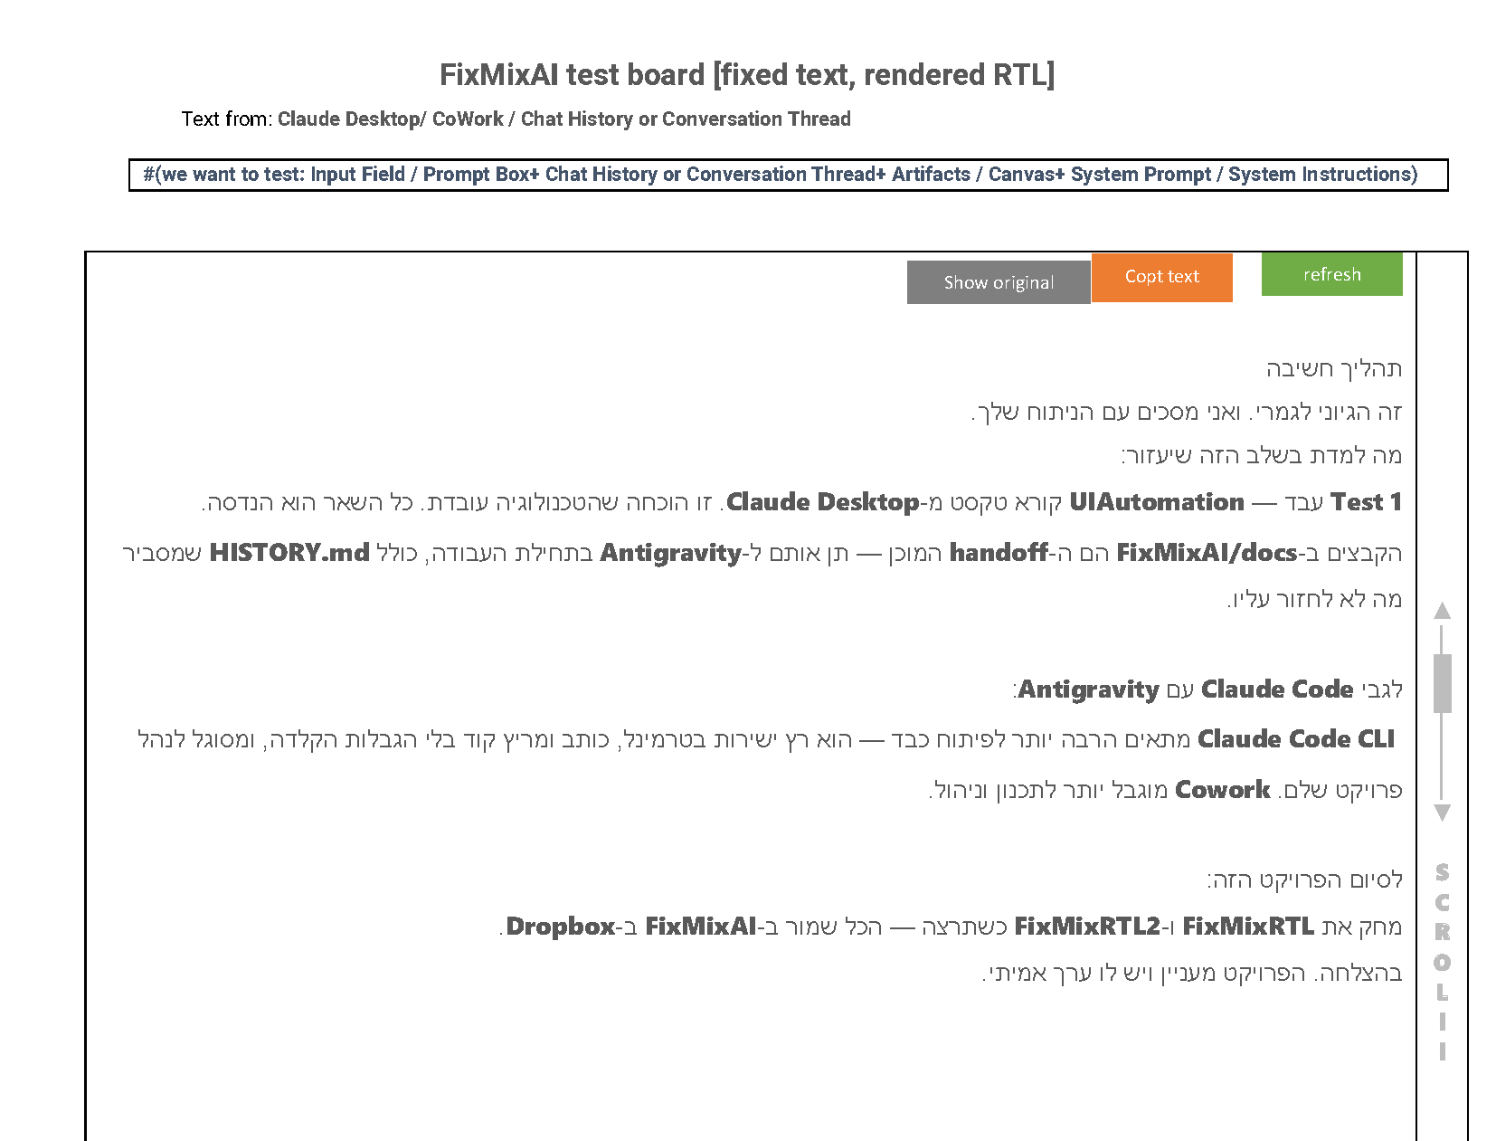
POC Wire frame:

We can run tests on Tsafrir's PC, Windows 11, with Claude Desktop (chat, cowork, code), Antigravity agents, and many more browser and desktop AI apps. Or in a sandbox or other method that would provide faster and better the answers then no need to test manually).
following after this chapter find list with tests for this phase.

Think, ask, and test any other element needed.
Then go to planning.
After the planning is done, start the developing.

### Phase 2 — an overlay designed app on the real AI text window or few windows at the same time. An app small desktop control panel to active, choose parameters, options and way to choose windows of interest.
- A personal desktop app for Tsafrir to experience.
- Features and design according to the planning.
- Full overlay covering the response area?
- Colored border showing overlay is active?
- Copy works?
- Interactive elements- not hiding/ the layer does not cover the interactive elements and the user can click on it+ adjusting RTL fixed text display in a way that will not cover the interactive element. Or other solution according to testing results.
- No performance issues?
Wire frame + design reference:
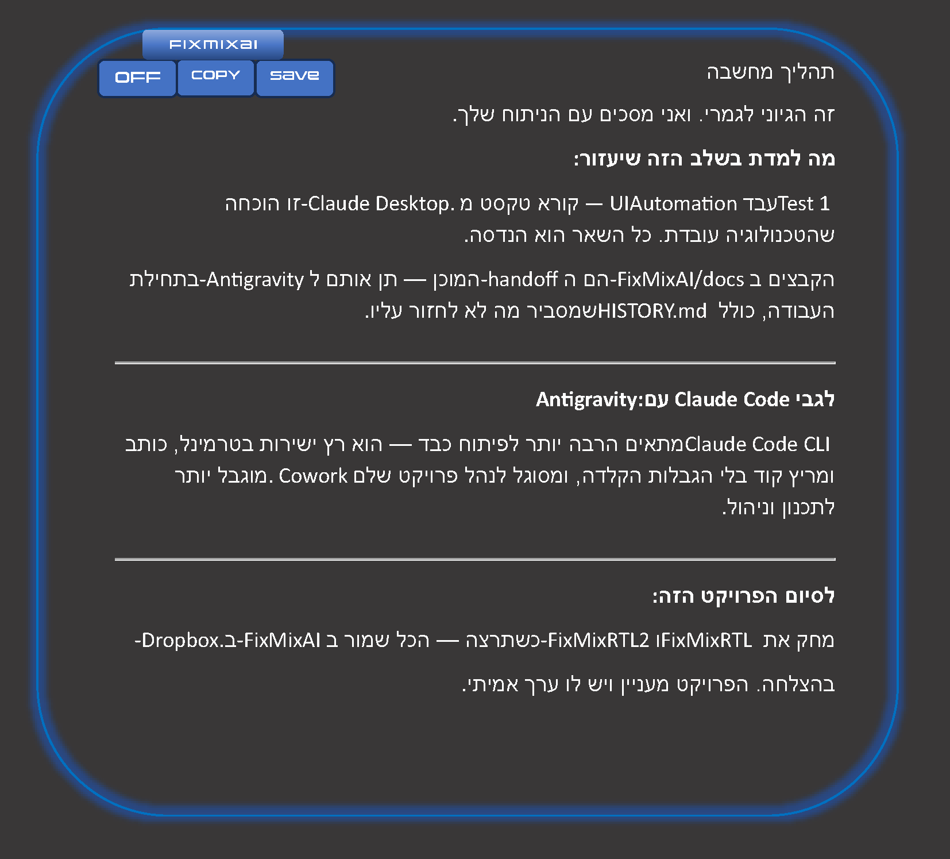

### Phase 3 — Commercial Version
- Installer for other users
- Code signing certificate (~$300/year, required for Windows distribution)
- Distribution website

---

POC Tests

### Test 1 — UiaBridge reads Hebrew from Claude Desktop
**Status:** ✅ PASSED (April 2026)
**What we tested:** Run UiaBridge.exe, open Claude Desktop, type Hebrew.
Check terminal output for Hebrew text + coordinates.
**Result:** Works. Reads text in real time with x, y, width, height per element.
**Implication:** Foundation is solid. UIAutomation can see inside Claude Desktop.

---

### Test 2 — RTL fix looks correct visually
**Status:** ⬜ NOT YET TESTED

**What we test:**
Run the POC window
Type a Hebrew+English mixed sentence in AI Desktop app.
Check: does the POC show the raw text (broken) and the fixed text (correct RTL)?

**What "correct" looks like:**
- Raw: "השתמשתי ב React כדי לבנות" — rendered LTR, Hebrew words scrambled
- Fixed: same text with RLI/LRI/PDI Unicode markers applied, rendering correctly RTL
with "React" staying in its natural position within the Hebrew sentence

**The POC window spec:** see POC_SPEC.md

**Test sentences to use:**
1. "השתמשתי ב React כדי לבנות את הממשק"
2. "הפרויקט משתמש ב TypeScript ו Node.js"
3. "ה API מחזיר JSON עם שדות של מידע"

---

### Test 3 — No mouse freeze
**Status:** ⬜ NOT YET TESTED

**What we test:**
- While FixMixAI is running and scanning, type text and move mouse normally.
Read "Important note for codind FixMixAI.docx" file at: C:\Users\ortsa\Dropbox\Apps and agents building\FixMixAI\docs\More info

**Pass:** No lag, no freezing.
**Fail:** Any noticeable freeze or lag during scanning.
**Risk:** UIAutomation polling can sometimes block the UI thread on Windows.
**Fix if fails:** Move scanning to a background thread with lower priority.
---

### Test 4 — Overlay follows window when moved
**Status:** ⬜ NOT YET TESTED

**What we test:**
Move the Claude Desktop/ other apps window across the screen.
Check that the overlay follows it exactly.
**Pass:** Overlay follows with less than 100ms lag.
**Risk:** WinEvent hooks update position asynchronously. Fast dragging may lag.

---

### Test 5 — User can select and copy from overlay
**Status:** ⬜ NOT YET TESTED

**What we test:**
Select text in the overlay window with mouse. Press Ctrl+C. Paste in Notepad.
**Pass:** Correct fixed Hebrew text is pasted.
**Risk:** Electron overlay may block text selection if configured incorrectly.

---

### Test 6 — UIAutomation distinguishes window areas
**Status:** ⬜ NOT YET TESTED

**What we test:**
Check if UiaBridge can tell apart: input area vs response area vs artifact panel.
**Why it matters:** We may want to fix ONLY the response area, not the input field.
**Note:** From Test 1, UIAutomation appears to focus on "write your prompt to claude"
(the input area). We need to verify it also reads the response/chat area.

---

### Test 7 — How much scrolled-back text is accessible
**Status:** ⬜ NOT YET TESTED

**What we test:**
Have a long conversation. Scroll up. Activate FixMixAI. Check how many messages back
UIAutomation can see.
**Risk:** UIAutomation typically reads only currently rendered DOM elements.
Virtualized lists (common in Electron apps) remove off-screen items from accessibility tree.
**Decision after test:** If scroll history is limited, the product shows current screen only.

---

### Test 8 — What element types can UIAutomation read
**Status:** ⬜ NOT YET TESTED

**What we test:**
Ask Claude Desktop to generate: plain text, a table, a code block with Hebrew comments.
Check what UiaBridge captures for each type.
**Why it matters:** Tables and code blocks may not be accessible as text.

---

### Test 9 — Performance: 2 windows from same app
**Status:** ⬜ NOT YET TESTED

**What we test: **
Open 2 Claude Desktop windows. Run FixMixAI on both.
Check CPU usage and whether both overlays update correctly.
**Decision after test:** If slow → one active overlay at a time (user selects which).

---

### Test 10 — Performance: 2 different apps
**Status: ** ⬜ NOT YET TESTED

**What we test:**
Open Claude Desktop + Cursor simultaneously. Run FixMixAI on both.
**Decision after test:** Same as Test 9.

---

### Test 11 — Overlay design matches wireframe spec
**Status:** ⬜ NOT YET TESTED

**What we test:**
Render the overlay window using the wireframe spec and compare visually to the original AI app text.
Check: does the overlay reproduce the correct font, font size, line spacing, padding, and colors?

**Design spec to match (from wireframe):**
- Background: white (#ffffff)
- Font: Segoe UI (system font on Windows) — fallback if user is missing a desktop font?
- Table borders: light gray (#e0e0e0)
- Fixed rows: light yellow background (#fffde7) to highlight what changed
- Raw text cell: monospace font (e.g. Consolas), direction LTR (shows the "broken" state)
- Fixed text cell: regular font (Segoe UI), direction RTL

**Sub-questions:**
- Can UIAutomation retrieve font name, font size, and line-height from the source app?
- If not, can we detect the app (Claude Desktop, Cursor, etc.) and use a known default style map?
- Does the overlay text look native enough that the user feels they are reading from the app itself?

**Pass:** Side-by-side comparison — overlay text matches the source app's visual style closely.
**Fail:** Text looks obviously different in size, spacing, or font — breaks the "seamless" feel.

---

### Test 12 — Identify and map interactive elements in AI windows
**Status:** ⬜ NOT YET TESTED

**What we test:**
Using UIAutomation, identify all interactive elements (buttons, input fields, links, dropdowns, comment areas, copy buttons, thumbs up/down, retry buttons) inside Claude Desktop and other AI apps.
Map their bounding rectangles (x, y, width, height).

**Why it matters:**
The overlay covers the response area but must NOT block interactive elements. This test determines whether we can reliably detect where interactive elements are, so that in Phase 2 we can create "holes" in the overlay (transparent/click-through regions) at those coordinates.

**Approach — Option A (Preferred for Phase 1):**
Locate each interactive element's bounding rectangle via UIAutomation. Mark those regions as click-through (WS_EX_TRANSPARENT or similar) in the overlay, so the user's clicks pass through to the original app underneath. This is simpler — no need to replicate the interactive element, just get out of its way.

**Approach — Option B (Research for future phases):**
Create a two-way bridge: render interactive elements (buttons, input fields) on the overlay that mirror the original app's elements. When the user clicks or types on the overlay copy, forward the event to the original app via UIAutomation's SetValue/Invoke patterns. This is more complex but would allow the overlay to fully cover the window without any holes.

**What to capture:**
- List of element types found (Button, Edit, Hyperlink, etc.)
- Their AutomationId or Name property (for stable identification across sessions)
- Their bounding rectangles
- Whether they change position when the user scrolls

**Pass:** We can reliably map at least: input field, copy buttons, and navigation links.
**Risk:** Some interactive elements may not have UIAutomation patterns exposed (especially custom Electron components).
**Decision after test:** Choose Option A or B for Phase 2 implementation.

---

### Test 13 — Click-through works for interactive regions
**Status:** ⬜ NOT YET TESTED

**What we test:**
Using the interactive element map from Test 12 (Option A), configure the overlay window so that specific rectangular regions are click-through (transparent to mouse events). Verify that clicks in those regions reach the original app.

**Steps:**
1. Identify the input field bounding rectangle via UIAutomation.
2. Create the overlay with a transparent/click-through hole at that rectangle.
3. Click inside the hole — does the original app's input field receive focus?
4. Click outside the hole (on the overlay) — does the overlay capture the click (e.g. for text selection)?

**Technical approaches to test:**
- WS_EX_TRANSPARENT + WS_EX_LAYERED on the overlay window, with per-pixel alpha for the holes
- Electron's setIgnoreMouseEvents(true, { forward: true }) for specific regions
- A hybrid: full overlay with setIgnoreMouseEvents toggled dynamically based on mouse position

**Pass:** User can type in the original input field while overlay is active. Copy buttons in original app respond to clicks.
**Fail:** Clicks are swallowed by the overlay even in designated pass-through areas.
**Risk:** Dynamic hole positions (elements move when user scrolls) may cause flickering or lag.
**Decision after test:** If click-through works reliably → Phase 2 uses Option A. If unreliable → investigate Option B (mirrored interactive elements) or limit overlay to non-interactive zones only.

---

## After All Desktop Tests Pass

Run the same test sequence on a Chrome browser window.
UIAutomation can read Chromium-based content (Chrome, Edge, Electron apps all use Chromium).
This would mean FixMixAI works for web-based AI tools too — a major expansion.

---

## Known Technical Risks

1. **Scroll limit** — UIAutomation may see only visible text. Test 7.
2. **DPI scaling** — coordinates need adjustment for 150%, 200% scaling screens.
3. **App updates** — Claude Desktop may update and change its accessibility tree.
4. **Window tracking** — overlay must follow in real time. Test 4.
5. **Interactive elements** — overlay must not block buttons or input.
6. **Code signing** — ~$300/year required before distributing to other users.

---

## Technical Architecture

### How It Works
1. UiaBridge.exe (C#) — runs as child process, reads text using Windows UIAutomation API
2. uia-bridge.ts (TypeScript) — manages the C# process, parses JSON output
3. rtl-detector.ts (TypeScript) — detects Hebrew characters (U+0590–U+05FF range),
applies Unicode BiDi markers (RLI, LRI, PDI) to fix direction
4. engine-controller.ts (TypeScript) — orchestrates the full pipeline
5. Electron renderer — displays results to user

### Unicode BiDi Fix Method
The fix inserts invisible Unicode direction markers:
- RLI (U+2067) — Right-to-Left Isolate: before Hebrew block
- LRI (U+2066) — Left-to-Right Isolate: before English block
- PDI (U+2069) — Pop Directional Isolate: after each block

This is the correct modern approach (Unicode BiDi Algorithm).
It does NOT alter the text content — only adds invisible formatting characters.

### Files That Work (Do Not Rewrite)
- native/UiaBridge/UiaBridge.exe — compiled C# binary, tested
- src/main/engine/rtl-detector.ts — detection and fix logic
- src/main/engine/uia-bridge.ts — C# process bridge

---

## How We Work

**Coordinator:** Gemini (always)
- Communication hub between all Sub-Agents and Tsafrir
- Owns and maintains PROJECT_DASHBOARD.md
- Does not write code or make technical decisions alone
- Explains all technical decisions to Tsafrir in plain language (Hebrew)
- Triggers TECHNICAL_BRAINSTORM when work is stuck or a decision is complex

**Sub-Agents:** Defined dynamically at project start using the AGENT_ROSTER skill.
- Gemini researches current model strengths before assigning roles
- Team is confirmed with Tsafrir before work begins
- Each Sub-Agent receives SUBAGENT_ONBOARDING at session start

---

## Skills & Rules Reference

**Coordinator global rules:**
- Global Rules (GEMINI.md) — Coordinator behavior, communication style, Hebrew/English handling
- WORKING_WITH_TSAFRIR.md — User profile, communication rules, health considerations

**Project Skills** (live in. agent/skills/):
- AGENT_ROSTER — Coordinator selects and defines the Sub-Agent team
- SUBAGENT_ONBOARDING — Sent to every Sub-Agent at the start of a session
- TECHNICAL_BRAINSTORM — Cross-agent problem solving when work is stuck
- SHARED_WORKSPACE — Dashboard structure and agent communication protocol

**Project Management: **
- PROJECT_DASHBOARD.md — Shared task board (created by Coordinator at project start)

